DAR ES SALAAM INSTITUTE OF TECHNOLOGY



# DEPARTMENT OF MECHANICAL ENGINEERING BACHELOR OF ENGINEERING IN MECHANICAL ENGINEERING

**NTA LEVEL 7**

DESIGNING OF TWO STAGE SPEED REDUCER GEAR BOX

**GROUP WORK**

## GROUP NO: 05

**CLASS:** BEING 19 - ME

**MODULE:** MEU 07208 **MODULE TITLE:** MACHINE ELEMENT **LECTURE’S NAME :** L. S. A Mgungo

**GROUP PARTICIPANTS**

|  |  |
| --- | --- |
| **NAME** | **REG. NO** |
|  |  |
|  |  |
|  |  |
|  |  |
|  |  |
|  |  |

**JULY, 2019**

**AKNOWLEDGMENT**

The satisfaction and euphoria that accompany the successful completion of any task would be incomplete without mentioning the people who have made it possible, because success is the epitome of hard work. So with gratitude, we acknowledge all those whose guidance and encouragement have made our efforts successful in this group.

We wish to express our deep sense of gratitude to our lecture **L S. A Mgungo** from the Department of Mechanical Engineering for his encouragement, which went a long way in the successful completion of this project.

We thank to every individual who has directly or indirectly influenced us to propel the project to its completion.

# ABSTRACT

The aim of this project is to design a gearbox that is compact, lightweight and has extended life. Major fields covered are Material selection, Machine Engineering Design of Gears, Shafts, Gearbox Casing, Bearing selection, Vibrations caused due to the Engine. The design is also finalized with the fits required for assembly and the final product is expected to be efficient, light weight, compact and long lasting.

After several calculations and assumptions depending on the type of the material and safety operations the two stage gear type of shafts diameters of 25mm, 30mm, 35mm, and Diameter of the two gears are 72mm and 144mm, face width 50mm, module 4mm, center distance 108mm, pitch 12.57mm, addendum 4mm, dedendum 5mm, working depth 9mm were selected.

Keyways dimensions of length 25mm width 8mm and height 7mm. Housing dimensions of 96x144x180. Bearing outer diameter is Ø52mm.

# TABLE OF CONTENT

ABSTRACT ii

TABLE OF FIGURES v

LIST OF SYMBOLS vi

INTRODUCTION 1

PROBLEM STATEMENT 1

OBJECTIVES 1

SIGNIFICANCE OF THE REPORT 1

SCOPE OF THE REPORT 1

LITERATURE REVIEW 2

THE GEAR BOX 2

REDUCTION GEARBOX 2

Types of Reduction Gearbox 2

COMPONENTS OF A GEARBOX 3

Casing 3

Gears 3

Gear Types 3

Shafts 4

Bearings 5

METHODOLOGY 6

DESIGN OF TWO STAGE SPEED REDUCER GEAR BOX 8

DESIGNING OF GEARS 8

DESIGN OF FIRST STAGE REDUCTION 8

Torque 9

Shaft Diameter 9

Number of Teeth 10

Pinion and Gear Diameters 10

Center distance (a) 11

Face width (b) 11

Circular pitch (Pc) 11

Addendum and Dedendum 11

Working depth (hk) 11

Whole depth (ht) 12

Maximum Clearance (C1) 12

Diametral pitch (P) 12

Outside Diameters 12

Filet radius (rf) 12

Pitch Velocity (v) 12

Sliding velocity (vs) 13

Gear Forces 13

GEAR STRESSES 14

Bending Strength 14

Fatigue Strength 14

Key design 16

Bearings 16

SEALS FOR GEAR BOX 17

Seal life 17

DESIGN OF THE SECOND STAGE GEAR REDUCTION 17

CONCLUSION 19

REFERENCES 20

APPENDIX 21

# TABLE OF FIGURES

Figure 1: SPUR GEAR 3

Figure 2: HELICAL GEAR 4

Figure 3: GEAR TOOTH GEOMETRY 4

Figure 4: BEARINGS 5

Figure 5: SPEED REDUCER GEAR BOX 17

# LIST OF SYMBOLS

α -Pressure Angle

a -Centre Distance

B -Face width

Cv -Velocity Factor d -Pitch diameter

d1 -Pitch diameter of pinion d2 -Pitch diameter of gear E -Young’s Modulus

Fs -Strength of Gear tooth Ft -Transmitted Load

i -Gear Ratio

K -Load Concentration Factor Kd -Dynamic load factor M -Module

Mt -Torque Transmitted by Pinion Pc-Circular Pitch Q -Ratio Factor

σc -Contact Stress

σb -Designed Bending Stress vm -Mean Velocity

y -Lewis Form Factor

Z -Number of teeth

Z1 -Number of teeth Pinion Z2 -Number of teeth Gear

Se -Endurance limit of the gear tooth Ka - Surface Factor

Kb -Size factor

Kc - Reliability Factor Kd -Temperature Factor

Ke -Modifying factor for Stress concentration Kf -Miscellaneous-effect

S , -Endurance limit of rotating-beam specimen n -Factor of Safety

e

# INTRODUCTION

## PROBLEM STATEMENT

Designing a two stage reduction gearbox using spur gears, with a single output speed. The output shaft is to be in line with the input shaft.

## OBJECTIVES

The main objectives of the report involve the Gear Designing, Shaft Designing, Key designing, Housing Designing, Bearing selection and Seals for Gearbox.

## SIGNIFICANCE OF THE REPORT

To ensure use of proper materials for each component of the gearbox. The design is done prior to manufacture and includes calculations of gear geometry taking into account gear strength, material selection, gear alignment and provisional for gear lubrication.

## SCOPE OF THE REPORT

The report is to be based on two stage gear system. This system is formed by three shafts connected to each other by two pairs of spur gears. The system can be used to reduce the gear speed thus increasing the torque available, change the direction of power transmission and distribute the available power between systems.

# LITERATURE REVIEW

## THE GEAR BOX

A Gearbox is a device that used for transmitting power from the Power source to the output shaft. A gearbox has a set of gears that are enclosed in a casing. The gears are mounted on shafts which rotate freely about their axis. The gears are fixed on the shafts by Fits or by a key. These shafts are made to rotate freely on a support called casing. Bearings are tightly fit between the shafts and the casing. Today’s cars have various sets of gears which give different speeds and torque on different Gears.

A Gearbox is necessary because it is impractical to directly connect the input source to the output shaft. The power source may not have enough torque to bear the whole load at once. This will put a load on the power source which may cause overheating, more fuel consumption or even failure of the components. Gearbox gives leverage to the power source by enhancing the torque at initial gears and then delivering high speeds at final stages. This reduces the capacity of the power source required and hence less fuel consumption. Each Gearbox has its own set of Gear ratios that can be selected by the driver or just one set of universal Gear Ratio that will work with the help of a Torque converter or Continuously Variable Transmission Major components include gears, Casing, Shafts, and Bearing.

## REDUCTION GEARBOX

A reduction gearbox is a device by which an input speed can be lowered for a requirement of slower output speed, with same or more output torque. Reduction gear assembly consists of a set of rotating gears connected to an output shaft. The high speed incoming motion from the wheel work is transmitted to the set of rotating gears, wherein the motion or torque is changed. The number of gears used in the reduction gear assembly depends on the output speed requirement of the application. The reduction gear assembly is usually known as reduction gear box. Depending on the Output speed required, the reduction may have single stage or two stage reduction.

## Types of Reduction Gearbox

There are mainly two types of reduction gears:

* Single reduction gear
* Double reduction gear

## Single Reduction Gear

This arrangement consists of only one pair of gears. The reduction gear box consists of ports through which the propeller shaft and engine shaft enters the assembly. A small gear known as a pinion is driven by the incoming engine shaft. The pinion directly drives a large gear mounted on the propeller shaft. The speed is adjusted by making the ratio of the speed reduction to the diameter of pinion and gear proportional. Generally, a single gear assembly has a gear double the size of a pinion.

## Double Reduction gear

Double reduction gears are generally used in applications involving very high speeds. In this arrangement the pinion is connected to the input shaft using a flexible coupling. The pinion is connected to an intermediate gear known as the first reduction gear.

The first reduction gear is then connected to a low speed pinion with the help of one more shaft. This pinion is connected to the second reduction gear mounted directly on the propeller shaft.

## COMPONENTS OF A GEARBOX

A Gearbox comprises of major components namely:

* + Casing
  + Gears
  + Shafts
  + Bearings

## Casing

Casing is a fixture that fixes all the shafts and assembles all gears into an assembly without any interference. Casing also contains the mounting points to mount it in a power train Assembly. The Casing takes the load imposed by the power source. Vibrations are also transmitted in case the power source is an Engine. Intricate shape is drawn on the casing to keep it from yielding. There are bearing sockets on the casing where the bearings are fit into the casing. Then the shafts are placed in the bearing. An inlet is created in casing to pour gear oil. The casing should be air tight as it accommodates space for the gear oil for cooling. The casing is usually a symmetric two piece setup that is used to open or close the gearbox for maintenance or repairs. The casing should be manufactured with utmost precision to avoid misalignment.

## Gears

A gear is a rotating machine part having cut teeth, which mesh with another toothed part to transmit torque. Geared devices can change the speed, torque, and direction of a power source. Gears almost always produce a change in torque, creating a mechanical advantage, through their ratio. The teeth on the two meshing gears all have the same shape. Two or more meshing gears, working in a sequence, are called a gear train or a transmission.

## Gear Types

* + Spur Gear and
  + Helical Gear Spur Gear

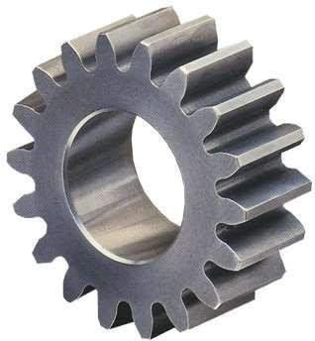Spur gears are mounted in series on parallel shafts to achieve large gear reductions. The most common gears are spur gears and are used in series for large gear reductions. The teeth on spur gears are straight and are mounted in parallel on different shafts. Spur gears are used in washing machines, screwdrivers, windup alarm clocks, and other devices.

**Figure 1: SPUR GEAR**

Helical Gear

Helical gears operate more smoothly and quietly compared to spur gears due to the way the teeth interact. The teeth on a helical gear cut at an angle to the face of the gear. When two of the teeth start to engage, the contact is gradual--starting at one end of the tooth and maintaining contact as the gear rotates into full engagement. The typical range of the helix angle is about 15 to 30 deg. The thrust load varies directly with the magnitude of tangent of helix angle. Helical is the most commonly used gear in transmissions.

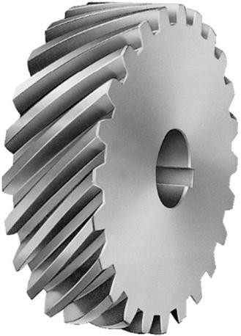

**Figure 2: HELICAL GEAR**

Key Terms on gears

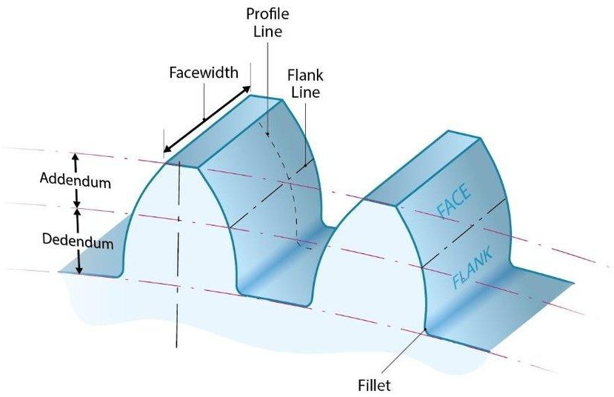

**Figure 3: GEAR TOOTH GEOMETRY**

## Shafts

A shaft is a rotating machine element which is used to transmit power from one place to another. The power is delivered to the shaft by some tangential force and the resultant torque (or twisting moment) set up within the shaft permits the power to be transferred to various machines linked up to the shaft. In order to transfer the power from one shaft to another, the various members such as pulleys, gears etc., are mounted on it.

## Bearings

Bearing is a component that ensures smooth rotation between the fixed support and the rotating shafts. These components are made of high carbon alloy steels that can bear huge amount of loads and rotate at high RPMs/There are two types of bearing--- Sliding contact bearing and rolling contact bearings. Sliding contact have a fluid between the inner and outer race that ensures smooth rotation. Rolling contact bearings also known as ball bearings have a handful of tiny hardened steel balls or rollers between the inner and outer race, these balls are super finished and have less friction compared to the sliding contact bearings.

These bearing have two types of loads acting on them namely Radial and Axial loads. These loads are calculated while making the gearbox. The outer race of the bearing is fitted into the casing and the inner race to the shaft.

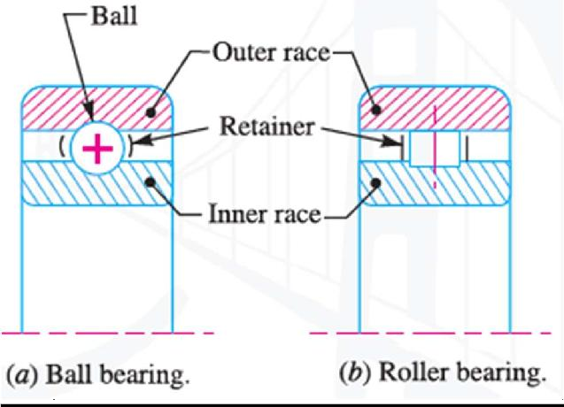

**Figure 4: BEARINGS**

# METHODOLOGY

**Shaft design formulas**

Power = Torque× Angular Speed

⬥  2 N

60

i= N1

N2

P = T  T  P  T  P

⬥ 1 

1

Shear Stress,

 D3

*16T*

3

**

*32T*

3

*b*

Bending Stress,

T =  D  D=

16

**Gear design formulas**

Number of teeth is given by : Lewis Bending Stress Equation,

Z = 2Fo  F = Safety Factor

i  Z2

Z

□  Ft  2T

1 sin2 o 1 b WmY WYZm2

Center Distance

Face Width

Pinion Diameter, d = mZ

a = m

Z1 + Z2 

Wmax

 4P  4 m

1 1

Gear Diameter, d = mZ

2 Where, m  Module 2 2

Addendum, add = m Dedendum, b= 1.25m

Working Depth, h = 2m Diametral Pitch, P = Z  P = Z1 = Z2

k

Whole Depth, ht = add + b Outside Diameters

d d1 d2

Maximum Clearance, C = 0.25m

For Pinion, d = Z1 + 2

1

Pitch Velocity,V = mZ11  mZ22

2 2

Sliding Velocity,Vs = JK 1  2 

But, JK = JP + PK

Where,

JK = Path of Contact JP = Path of Approach

PK = Path of recers which is given by,

d

 *d*

 *2 + add*    *2 cos*  

*2*

 *d*

*2* 

 *2*



 *2*

 

o1

For Gear, do2

P

 Z2 + 2

P

d

 *d*

 1 *+ add*    1 *cos*  

*2*

 *d*

*2* 

 *2*



 *2*

 

JK 

− 2 sin 

2

* 1 sin 2

**Gear forces**

Tangential Force, Ft

Where

T = Torque to be Transmitted



r1 = Pinion Radius

Radial Force, Fr Fr  Ft tan Normal Force, Fn

Fn 

*F* 2  *F* 2

*t r*

**Gear stresses**

From Lewis Bending Stress Equation,

b 

Ft Wpy

Where, Ft  Tangential Force W  Face Width

p  Circular Pitch

y  Lewis Form Factor

**Fatigue strength**

The Endurance limit for the gear tooth is obtained by : S = k k k k k k S ,

*e a b c d e f e*

**Factor of safety**

Factor of Safety n,

ηG = KOKmη

KO=overload factor

Km  Is an AGMA load - distributin factor

**Housing design**Total length, L= ls+bw+(2×th)

Housing height; H = d1 + m+ d2 + m+ 2s+ 2th Housing width; w = d2 + 2m+ 2 s+th 

## DESIGN OF TWO STAGE SPEED REDUCER GEAR BOX

## DESIGNING OF GEARS

The first criteria in designing the gears are to keep them simple, less weight and at the same time to keep the cost as low as possible. So, the weight and cost have their respective weight during the design such that both the parameters could be worth enough.

The machinability is another important consideration.

**Type of gear used:** Spur Gear with full depth involute teeth.

The following the parameters required to obtain the required gear profile.

* Number of teeth
* Module
* Gear Ratio
* Circular Pitch
* Diametric Pitch
* Pitch Circle Diameter
* Addendum
* Addendum circle Diameter
* Dedendum
* Dedendum circle Diameter
* Centre Distance
* Clearance
* Face width

## DESIGN OF FIRST STAGE REDUCTION(Helical gear):

Overall gear ratio, i = 4 Input power = 3.73kW

Input Speed, N1 = 2000rpm Pressure Angle, θ = 200

helix angle α=30

From,

Selected module m is 2mm from catalo

## Number of Teeth

For pinion, the number of teeth is given by:

  
Then we take Z1=24 since Z1≥22.1

For gear , Z2



## Pinion and Gear Diameters

Now,

Pinion Diameter, d1 = mZ1 = 4×24 = 96mm Gear Diameter, d2 = mZ2 = 4× 48 = 192mm

## Center distance (a)

a= m Z1 + Z2 = 4 24 +48  = 144mm 2 2

**Face width (b)** Wmax  4P  4 m Where, m  Module

Wmax = 4 m= 4 × 4 = 50mm

## Circular pitch (Pc)

Circular Pitch   m

P   m   × 4 = 12.57mm P  12.57mm

## Addendum and Dedendum

Addendum, add = m Dedendum, b= 1.25m

add = 4mm b= 1.25× 4 = 5mm

## Working depth (hk)

Working Depth, hk = 2m

hk = 2× 4 = 8mm

## Whole depth (ht)

Whole Depth, ht = add +b

ht = 4 + 5 = 9mm

**Maximum Clearance (C1)** Maximum Clearance, C1 = 0.25m C1 = 0.25× 4 = 1mm

## Diametral pitch (P)

## Diametrial pitch ,

## 

## Outside Diameters



## Filet radius (rf)

Fillet Radius, rf = 0.3m

rf = 0.3× 4 = 1.2mm

## Pitch Velocity (v)

## 

## Sliding velocity (vs)

Sliding Velocity,Vs = JK 1  2 

But, JK = JP + PK

Where,

JK = Path of Contact JP = Path of Approach

PK = Path of recers which is given by,



JK = 21

Vs = 21 209.44 +104.72



## Gear Forces

Tangential Force, Ft

F = T

*t*

Where T = Torque to be Transmitted

r1

r1 = Pinion Radius

F = 17.81

 371.04N

t 48×10-3

Ft = **0.371kN**

Radial Force, Fr



axial force, Fa



Normal Force, Fn



## GEAR STRESSES

## Bending Strength

From Lewis Bending Stress Equation,

b 

Ft Wpy

Where, Ft  Tangential Force W  Face Width

p y

→ Circular Pitch

→ Lewis Form Factor



## Fatigue Strength

The Endurance limit for the gear tooth is obtained by : S = k k k k k k S ,

*e a b c d e f e*

Where by :

Surface Factor obtained as :

Since the material used is Steel, then the ultimate tensile strength is, Sut = 600MPa

Then From the surface finish factor table displayed below kb is obtained

ka  0.742

From the table of size factor kb = 0.5 For Module of 4mm

For the Reliability Factor of R = 0.99 From the Table below

kc = 0.814

For Working Temperature below 3500 C T  3500 C

kd = 1

For Sut  1400MPa

k f  1.33

S , = 0.5S

*e u*

S , = 0.5×600 S , = 300MPa

*e*

*e*

S = k k k k k k S ,

*e a b c d e f e*

S = 0.742×1×0.814×1×1×1.33× 30×106

*e*

Se = **241MPa**

Factor of Safety n, From,

nG  Ko Kmn

Ko  Overload Factor which is equivalent to 1 for uniform power source and,

Km  Is an AGMA load - distribution factor which is 1.3 for accurate Mounting

□  Ft KvWmJ

1/

 78  2

Kv =  1 

 78 + 200V  2 

 

V  Pitch line Velocity = 4.52 m sec

1





Kv  

2

78 

1

= 0.85

 78 + 200× 4.52 2 

 

W  Face Width = 50mm

Ft  Transmitted Load  2.21kN

J  AGMA geometric Factor obtained from the Table J  0.339

n  K K n  Se

G o m 

K K n  Se

o m 

□  2210 = 38.2MPa

0.85× 50× 4×0.339 

1×1.3× n 

241MPa

* 1. MPa

 6.34

n  6.34  4.9

1.3

n  **5**

For AGMA practice n  2 hence it is safe to guard against fatigue failure

## DESIGN OF SECOND STAGE REDUCTION:

## GEAR DESIGN

## SECOND STAGE GEAR REDUCTION

## Overall velocity ratio i=4

## Input speed n =1000rpm

## Input power =3.73Kw

## Pressure angle= 20

## Input torque= 35.62Nm

## Velocity ratio, i = ZB/ZA=NA/NB For two set of gears.

## Hence i=ZD/ZC=NC/ND

But NB=NC

NB= (ZA/ZB) NA and NC= (ZD/ZC) ND

(ZA/ZB) NA = (ZD/ZC) ND

ND = (ZA/ZB) (ZC/ZD) NA

NA/ND = (ZB/ZA) (ZD/ZC) = (Velocity ratio i=1/2x1/2=1/4)

Driver, (Pinion): Number of teeth, Z1 Ø=20⁰, Taking Z1=20 teeth

rom, Z2 = i, Velocity ratio, i=2 for two set of gears A and B. Z1

Also for speed of revolution, N2= N1/i

ώ3 = 2ΠN2 = 2Π 1000= 104.72 rad/s 60 60

Z2=i  Z1=2x20 teeth Z2=40 teeth

N2=1000 rpm

ώ3 = 104.72rad/s.



Gear diameters d2; For pinion d1;

From; d = mZ, where ‘m’ is module and Taking m = 4mm in my design.

Pitch velocity V = (mZώ)/2

**Pitch velocity, v =4.189 m/s**

V = (4 x 10-3 x 20 x 104.72)/ 2

Sliding velocity (Vs) VSmax = JK (w1 + w2) Where; JK = path of recess

= [½(d2 + a)2– ½(d2CosØ)2]1/2 _1/2d2SinØ + [ ½(d1 + a )2– ½(d1CosØ)2]1/2– 1/2d1SinØ JK = [½(160 + 4)2– ½(160Cos20⁰)2]1/2 –½(160Sin20⁰) + [½(80 + 4)2– ½(80Cos20⁰)2]1/2– ½(80Sin20⁰)

JK =√(13448-11302.68)-27.36+√(3528-2826)-13.68 JK = 31.78.mm

Vs = 31.78 x (209.44 + 104.72) = 314.16 x 31.78=9984mm/s

**Vs = 9.984m/s**

Circular Pitch, P P = πm = 4π

**P = 12.57mm**

Addendum, a = module, m

**a = 4mm**

Dedendum, b = 1.25m = 1.25 x 4

**b = 5mm**

Working depth, hk;

hk = 2x module = 2 x 4mm

**hk = 8mm**

Whole depth,ht; ht = a + b = 4+5

**ht = 9mm**

Tooth thickness; t; t = πm/2 = 4π/2

**t = 6.28mm**

Face width/Tooth width; w w =4πm =4 x 4π

**w =50.27mm**

Maximum Clearance;

C1 = 0.25 x module = 0.25 x 4m = 1mm

**C1 = 1mm.**

Outside Diameter, do

d0 = (Z1 + 2) / p, Where p-diametral pitch

p = Z/d, P =Z1/d1 = Z2/d2 p = 20/80 =40/160

**p = 0.25mm**

For Pinion, d01

d01 = (Z1 + 2) / p = (20 + 2)/0.25

**d01=88mm**

For Gear; d02

d02 = (Z2 + 2)/p = (40 + 2)/0.25

**d02=168mm**

Fillet diameter of basis rf rf=0.3 x module = 0.3 x 4mm

**rf= 1.2mm**

GEAR FORCES;

Tangential forces, ft = T/r1, T – torque transmitted, r1 – radius of driver Ft = 8.905 Nm / (80/2 x10-3) m

**Ft = 222.625N**

Radial forces,Fn Fr = Ft.tanØ

= 222.625 x tan20⁰ N

**Fr = 81.029N**

Normal force, Fn

Fn = √2 + 2 = [(222.625)2+ (81.029)2]1/2

**F n= 236.91N**

**GEAR STRESSES;**

Lewis’ bending moment equation;

σb = Ft/wpy’ w – Face width p – Circular pitch y – Lewis factor

w =4xP=50.265mm

Ø = 20⁰, P =12.57mm, b = 5mm, a = 4mm, y = 0.30769 (from the table)

For Pinion Z1 = 20teeth

σb = 222.6/(50.265 x 12.57 x 0.30769) σb= 1.151N/mm2

Fatique strength:

Ka=0.742, for m=4mm, Kb=0.930 For; 95% Reliability, Kc=0.868 For T≤ 350°C, Kd = 1

The endurance strength is given by: Se= Ka.Kb.Kc.Kd.ke.Kf.Se’

Se’=0.5 Sut

For cast iron/steel, Sut=600Mpa, (from Design of machine element) Se’ = 0.5×600Mpa

Se’ = 300N/mm2

Kc=1, (known as a unity)

For Sut ≤ 1400Mpa Kf=1.33

Se=0.742×0.930×0.868×1×1×1.33×30x106= 239Mpa = 239Mpa

Factor of safety, Ks; Ks= Ko Km n= Se/σ

Where: σ = Ft/ Kv. W m J And:

Kv = [78/ (78 + (200v) 1/2)]1/2

For high precision, sheared or ground teeth with appreciable dynamic load. V=pitch line velocity, v=8.38 m/s

Kv= 0.810

AGMA geometrical factor for teeth;

Ø =20°c, σ=m=4mm, b= 1.25m= 5mm J=0.35176 + (40-35) / (50-35) (0.35804-0.35176) J=0.35385

σ = Ft/KvWmJ = 222.625 / (0.810 × 50.265 ×4 ×0.35385) = 3.9 N/mm2

61.3= (1×1.3) n n=61.3/1.3= 47

= 3.9 Mpa

Ks= Se/σ = 239Mpa/3.9Mpa =61.3

From: Ks=Ko.Km.n Ko- overload correction factor

Km- L0ad distribution factor

Ko= 1, for uniform source of power and uniform driven machine.

Km= 1.3 for accurate mounting small bearing clearance, minimum deflection, precision gear and face width O-50mm.

**Factor of Safety 47.15.**

Since; n≥2; According to AGMA, it is safe.

## SHAFT DESIGN

## Torque

Power = Torque× Angular Speed

P = T  T  P  T  P

1

⬥ 1

3730

T1 

209.44

Also,

T1 17.81 **Nm**

T2  

*P*

2





There Fore,

Transmitted Torque, T1 = 17.81Nm

Counter shaft Torque, T2 = 35.62Nm

Output shaft torque =71.24Nm

## Input Shaft Diameter

Material Selected for the shaft is Mild Steel with,

Shear Stress, =

For Shear Stress,

 D3

3

*16T*

**

T =  D 

16



Pinion Shaft diameter, D = 15mm

**Counter Shaft Diameter**

For Shear Stress,



Diameter of counter shaft will be 20mm

**Diameter of output shaft**

For Shear Stress



Diameter of output shaft will be 25mm

**Key design**

For Bending Stress, b  84MPa and Shear Stress,   42MPa

The Length of the Key is given by the Face width. L= W = 50mm

KEY LENGTH

From Roymech Standard Keys For shaft Diameter of 25mm key height, h = 7mm

key width, b = 8mm

A 7×8×50

For shaft Diameter of 20mm key height, h = 6mm

key width, b = 6mm

A 6×6×50

For shaft Diameter of 15mm key height, h = 5mm

key width, b = 5mm

A 5×5×50

## Bearings

For Input shaft Diameter, d = 15mm

For counter shaft Diameter, d = 20mm

For for output shaft Diameter, d = 25mm

BEARING SPECIFICATION

|  |  |  |  |
| --- | --- | --- | --- |
| BEARING N0 | BORE (mm) | OUTSIDE DIAMETER (mm) | WIDTH (mm) |
| 202 | 15 | 35 | 11 |
| 204 | 20 | 47 | 14 |
| 205 | 25 | 52 | 15 |

GEAR BOX HOUSING

Material : Cast iron

Centre distance between shafts;

L =  D1 + D2  = 96  192 

2 2

L = 144mm

Shaft length, Ls

Taking the distance between gears

 90 mm

Bearing width

 15 mm

Space behind bearings

 5 mm

Distance between gear and bearing

 10 mm

Gears width Then,

 50 mm

Ls  90 + 2×15+10 + 20 + 2× 50

Ls = **250mm**

Total housing length, L= Ls+ bw+(2× th)

L = 250 +15 +(2× 4)= 273mm

Total length= **273mm**

Housing height; H = d1 + m+ d2 + m+ 2Bw + 2th

H = 72+ 4+144  4+ 2 15+ 2 4 H = **262mm**

Housing width; w

w= d2 + 2m+ 2 Bw + th w= 144 + 2× 4 + 2 15 + 4 

w= **190mm**

## SEALS FOR GEAR BOX

Seals for gear box needs be of the following type

* + - Can be used at high speed and continuous shaft rotating
    - Positive ability to resist pressure, temperature and shaft speed
    - Tolerance of variety of lubrication conditions
    - Relatively high intensity of dimension variations
    - Low cost

## Seal life

Long life for seal is 1000 operating hours. Medium life leakage begins at 400 hours to 600 hours of operation.

Seal material

* + - Silicon: Good abrasion resistance Temperature range 270c to 2600c

sing, bearing and seals.

# REFERENCES

Handbook of gear design by “Gitin M Maitra” 2nd edition. Machine Design by R S Khurmi by S Chand & company Ltd. Design Data book by Mc-Grawhill (2nd edition).

Patel, Mitesh, A. V. Patil, Mitesh Patel, and A. V. Patil. "Stress and Design Analysis of Triple Reduction Gearbox Casing." International Journal 2: 106-111.

Design basics of industrial gearbox by Andrzej Maciejczyk & Zbigniew Zdziennicki, Department of vehicles and fundamentals of machine design (technical university of Lodz).

Patnaik, Siddhartha. "DESIGN FAILURE MODES AND EFFECTS ANALYSIS (DFMEA) OF AN

ALL-TERRAIN VEHICLE." International Journal of Research in Engineering and Technology Design of Machine Elements 6th edition1998 BY V.B.BHANDARY.

Puttapaka Nagarju & Ch. Ashok Kumar (2014), “Modelling & analysis of 2- stage reduction gearbox”; IJMETMR; ISSN nobr-2348-4845, Volume No: 1 (2014); Issue No: 12 (December).

# APPENDIX

